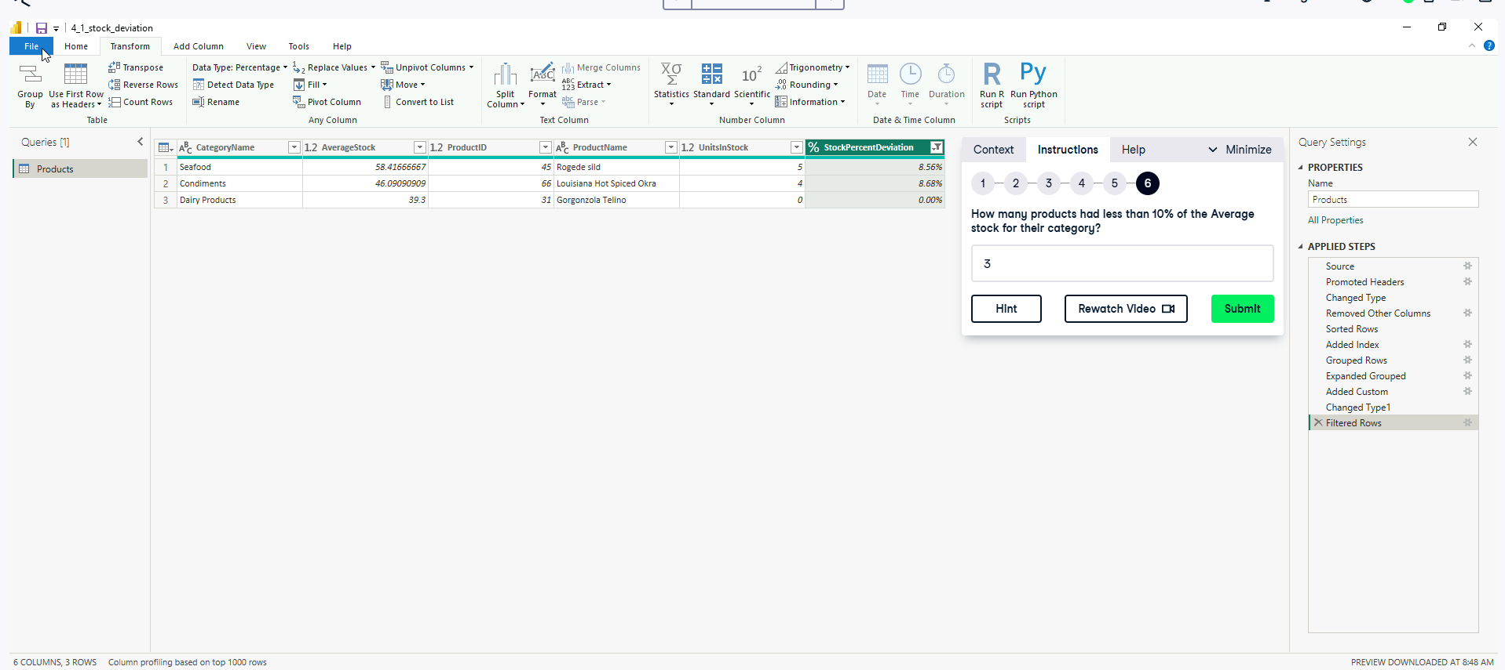**Data Analyst in Power BI Data-Camp 2025**

**Section 6: Data Transformation in POWER BI**

1. **Reshaping Data**

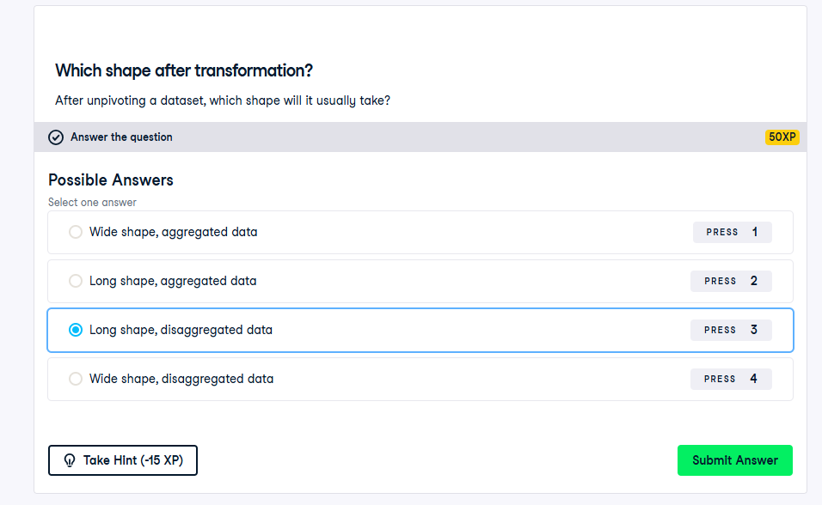

**

**Exercise 1.3**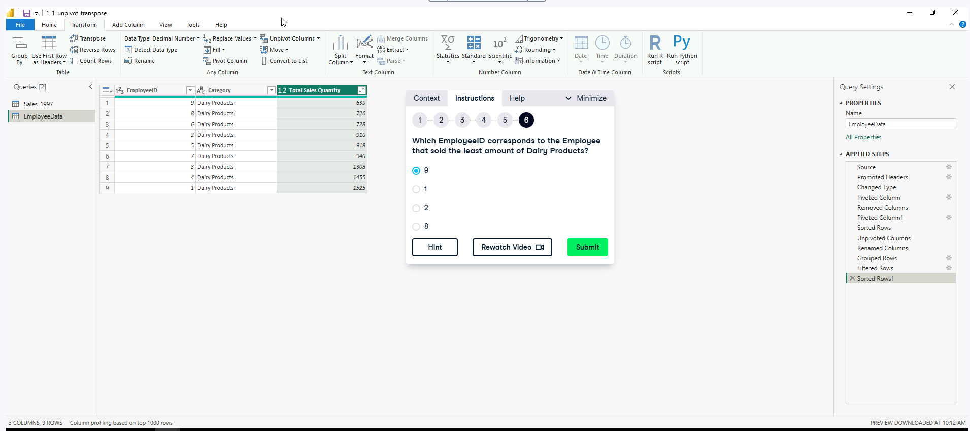

**2. Combining Data in Power Query** 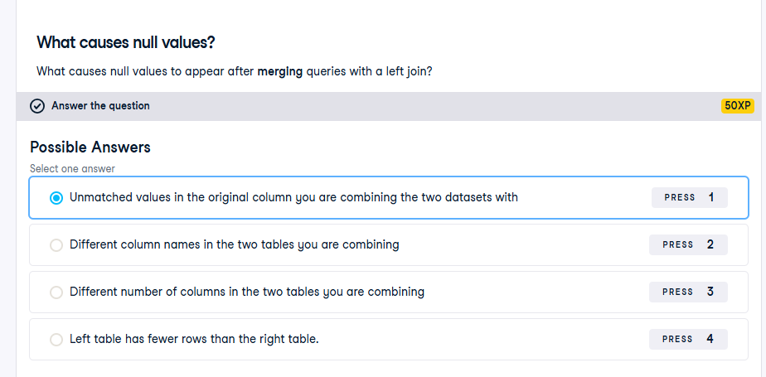

**Exercise 2.1**

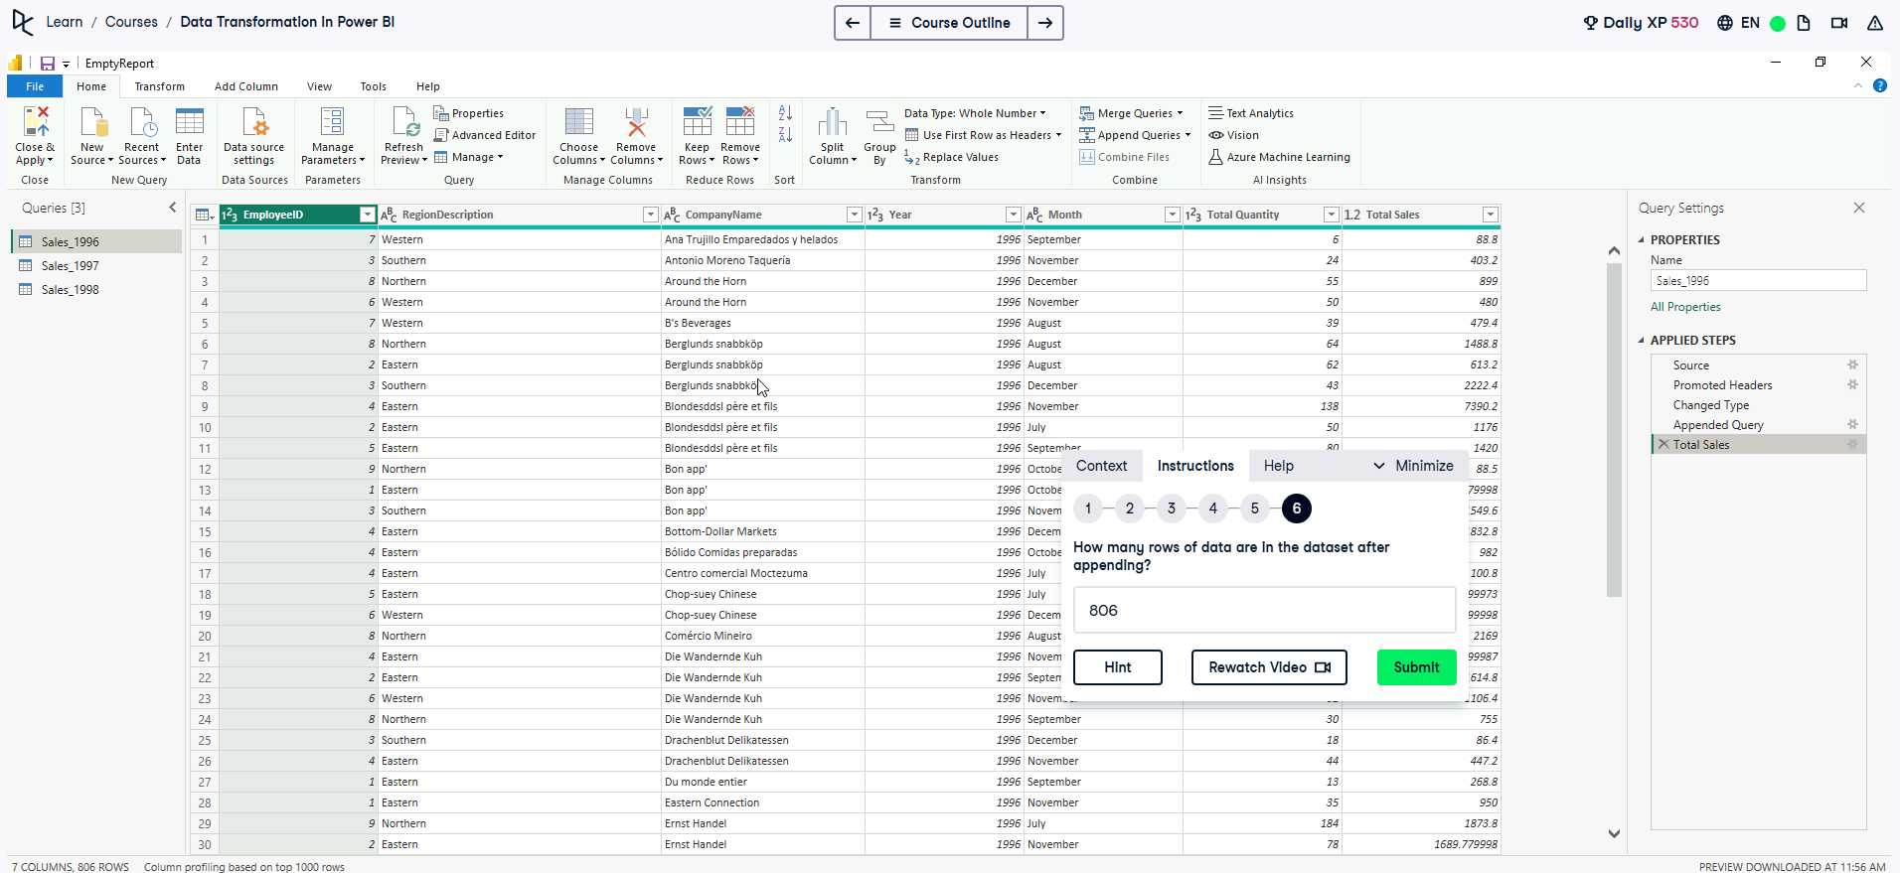

**Exercise 2.2**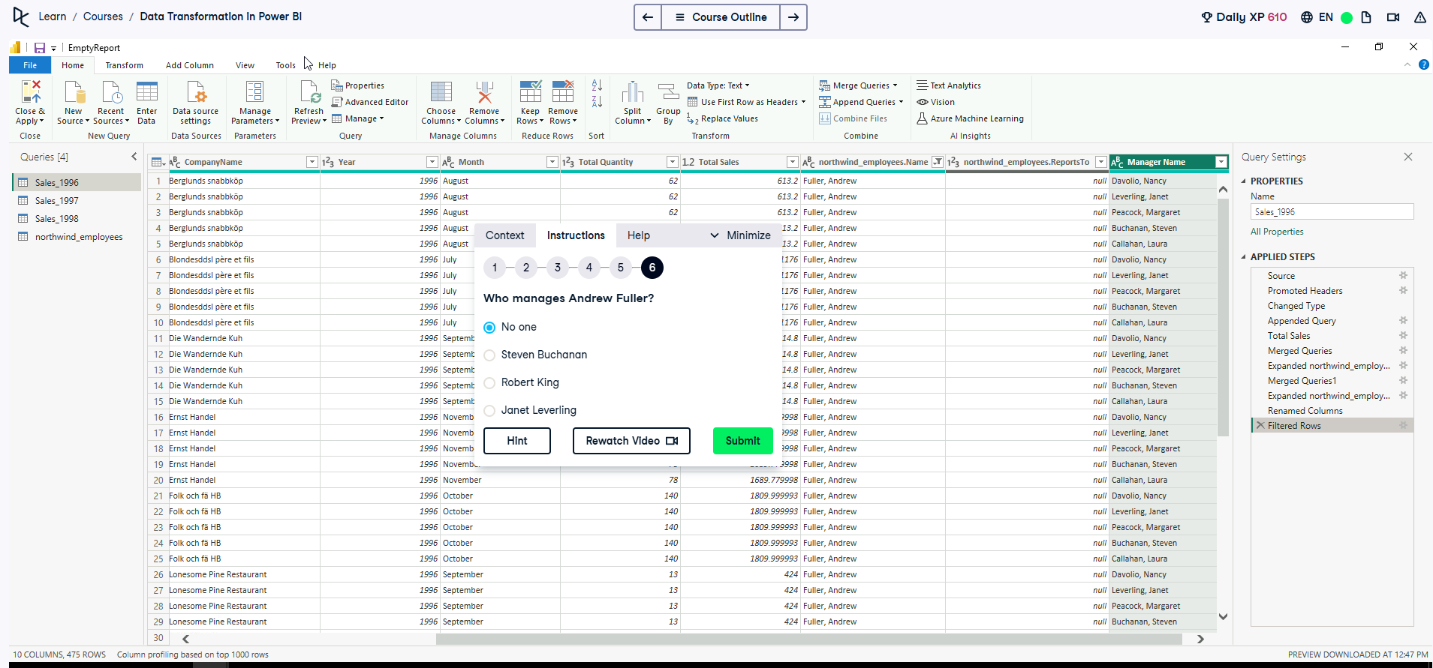

**Exercise 2.3**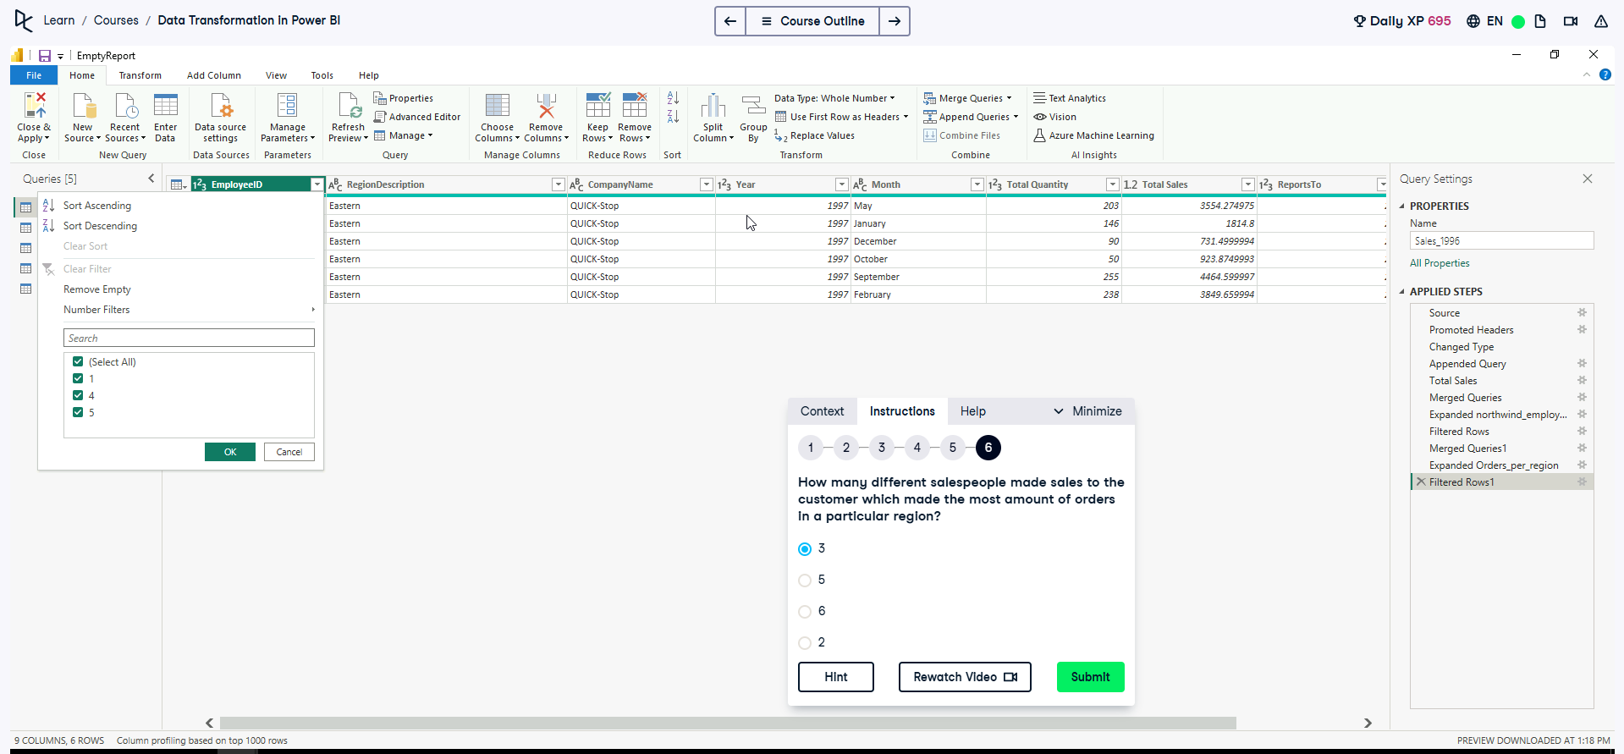

Count unique Employees ID to retrieve different salespeople, filter out the greatest/max value from orders to achieve this.

**Exercise 2.4**

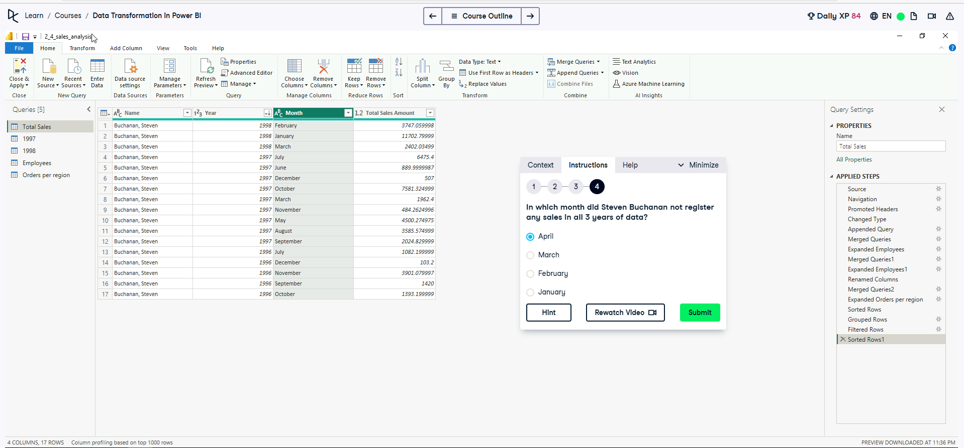

1. **Custom Columns A screenshot of a computer

   AI-generated content may be incorrect.**

**Exercise 3.1**

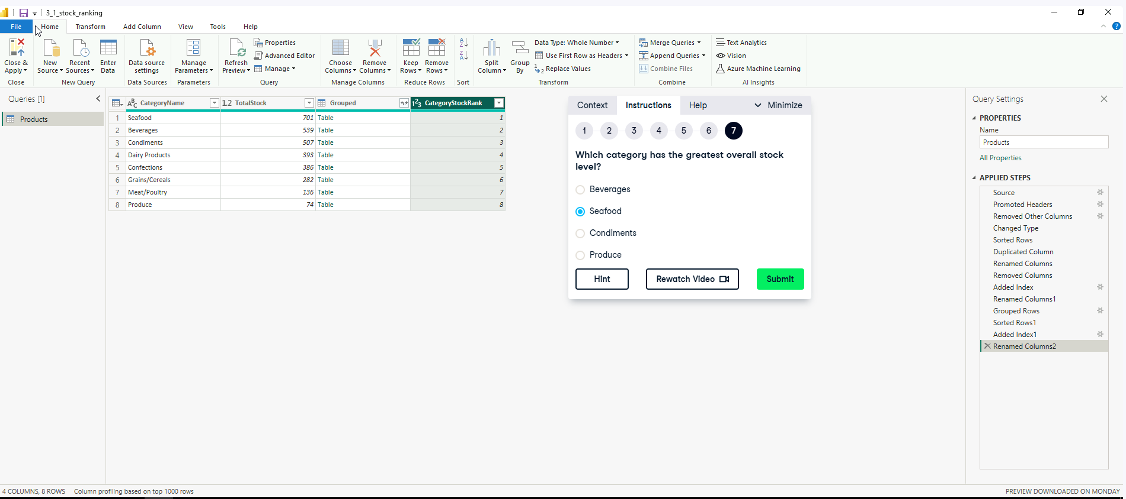

**Exercise 3.2**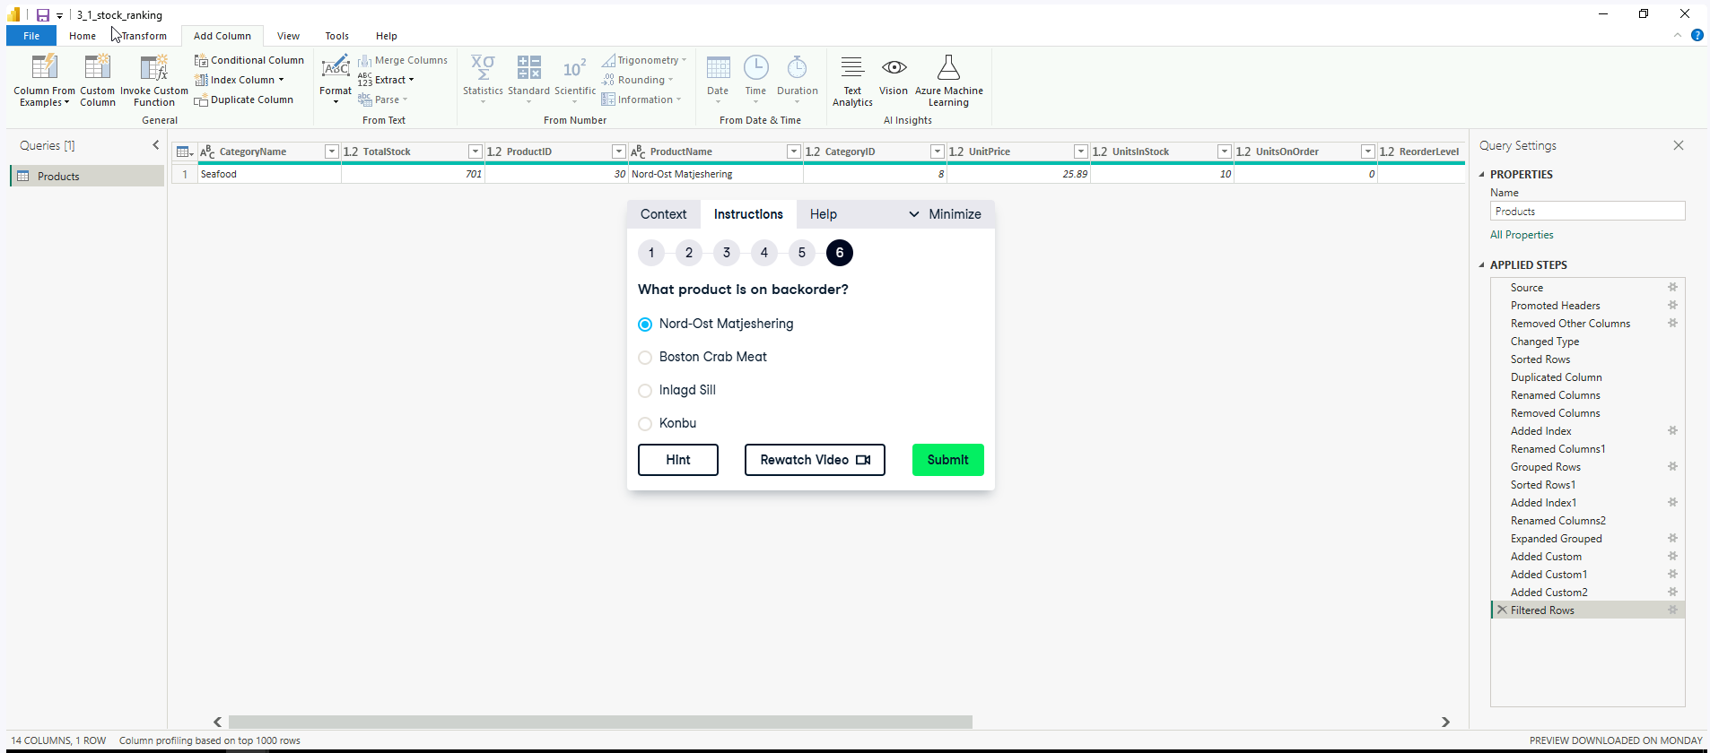

**Exercise 3.3**

Enquires for the following steps 3 and 4

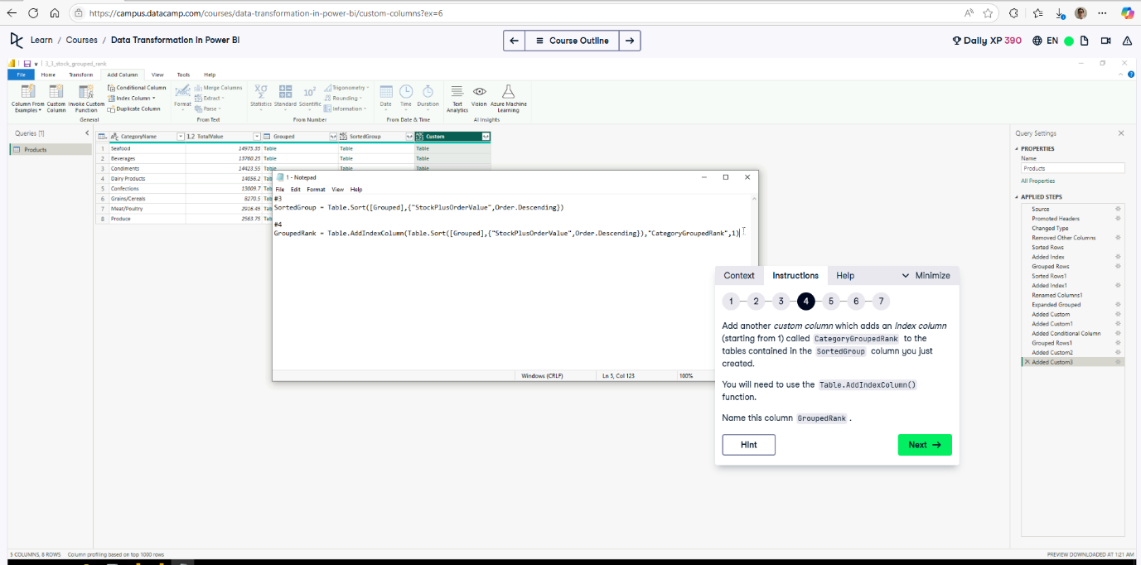

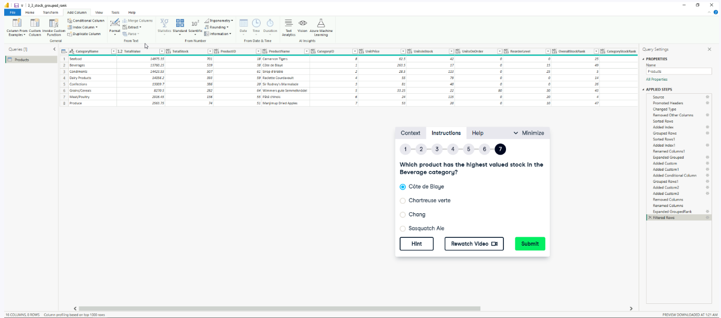

1. **Advanced Editor** 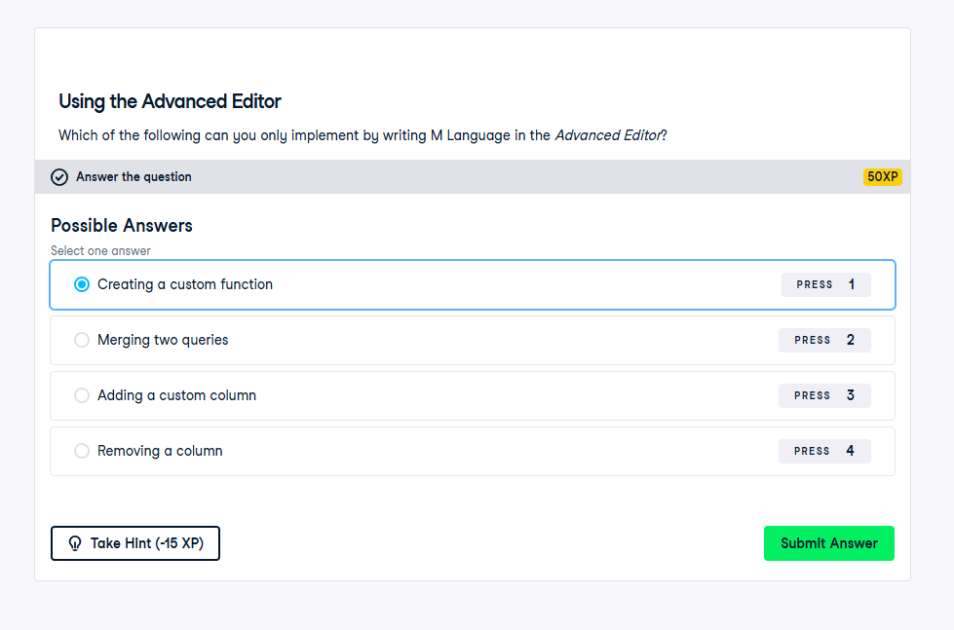

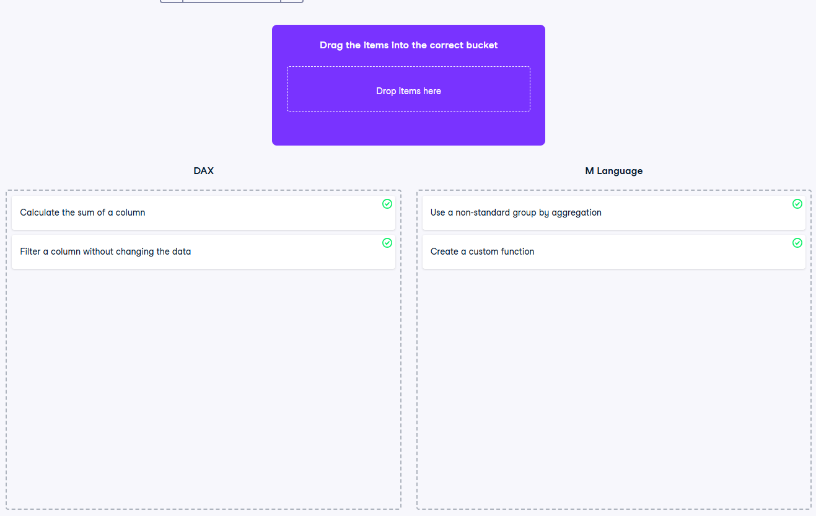

**Exercise 4.1**

**Exercise 4.2**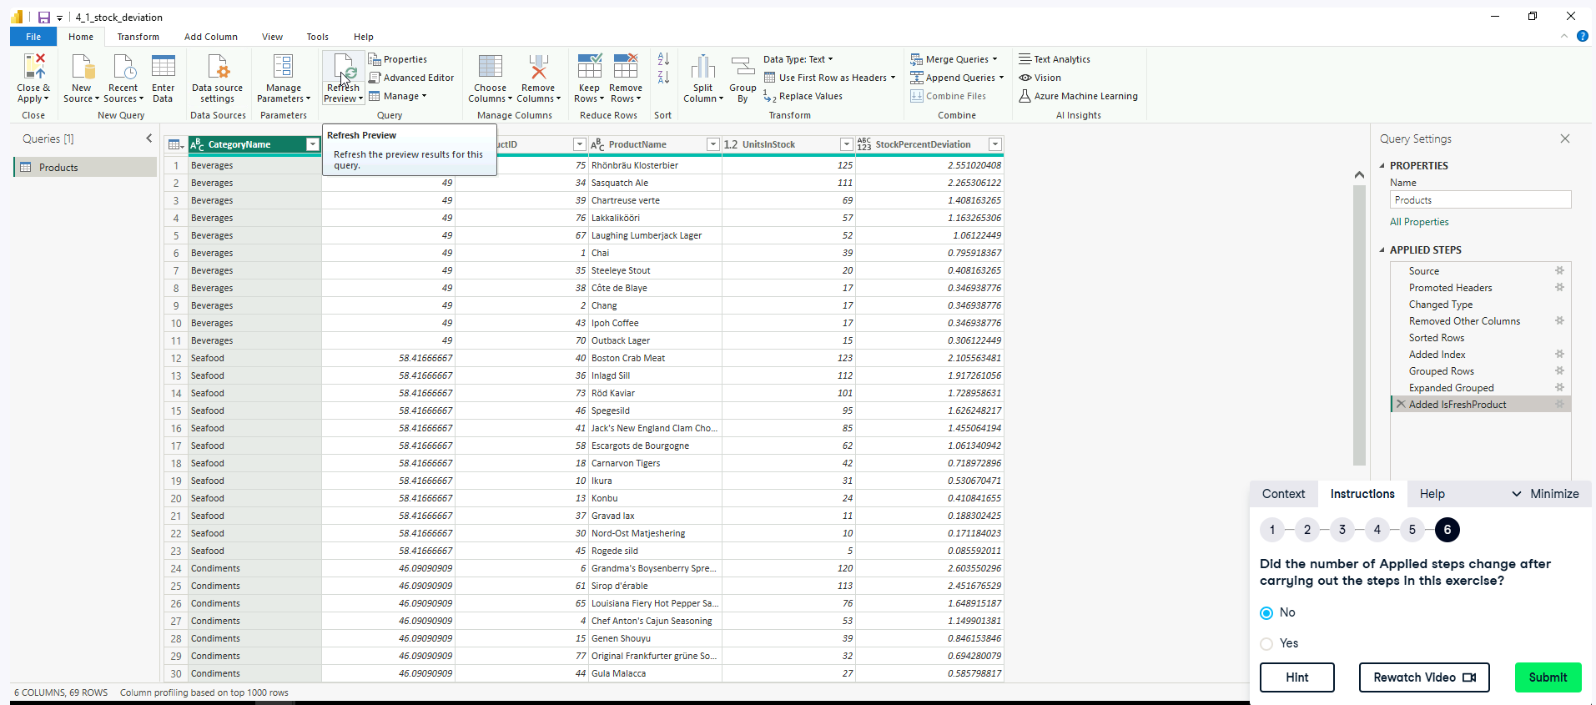

Make sure using Advanced Editor make sure the Added Custom 1 is renamed as Added IsFreshProduct for each instance.

**Exercise 4.3**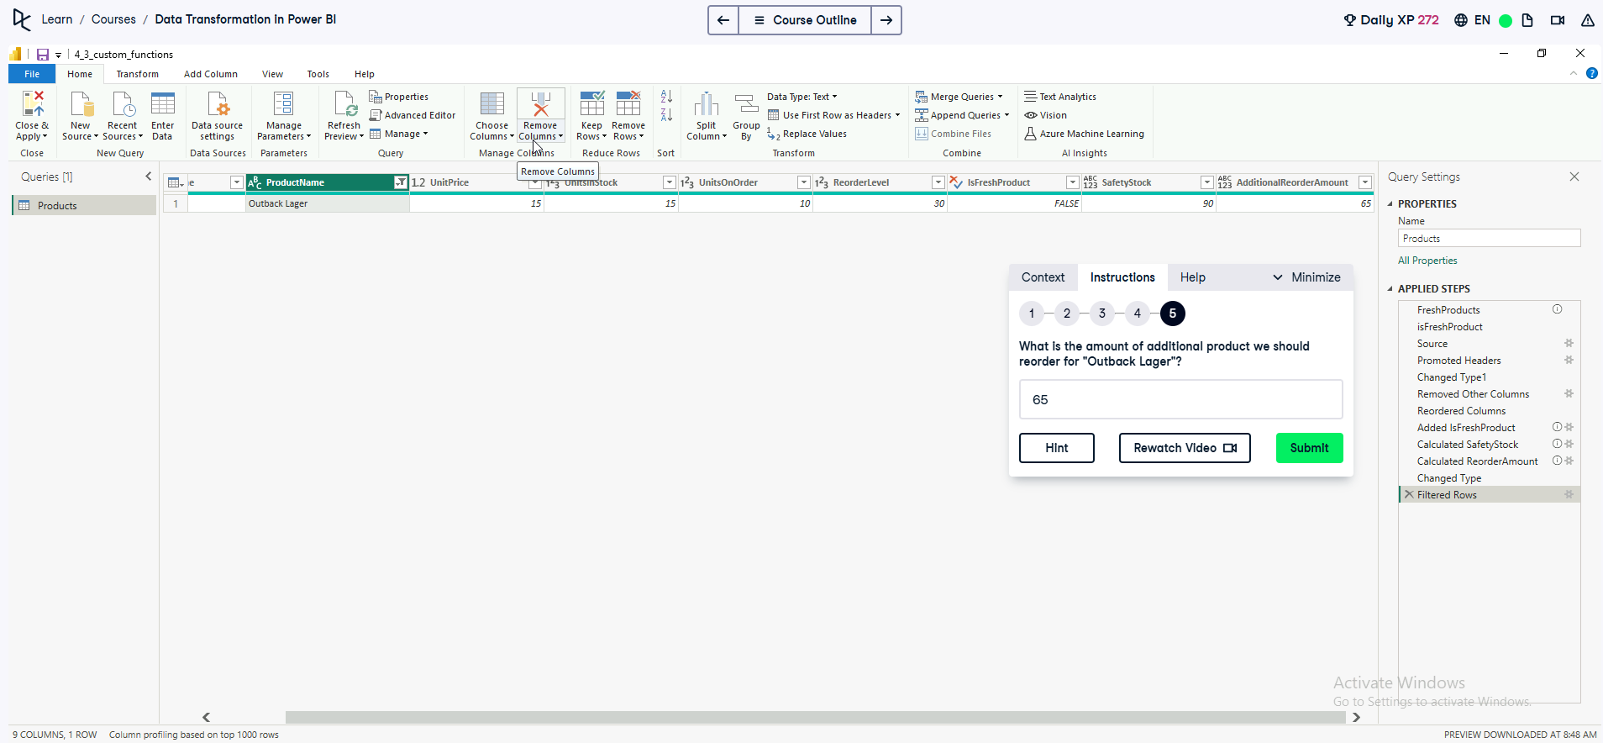

If lost, open the Exercise 4.3 PowerBi file.

**